**THE OSCILLOSCOPE**

**LAB # 01**



**Fall 2021**

**CSE-203L Circuit & Systems-II Lab**

Submitted by: **Suleman Shah**

Registration No. : **21PWCSE1983**

Class Section: **C**

“On my honor, as student of University of Engineering and Technology, I have neither given nor received unauthorized assistance on this academic work.”

Submitted to:

**Engr. Faiz Ullah**

11th October, 2022

**Department of Computer Systems Engineering**

**University of Engineering and Technology, Peshawar**

**OBJECTIVES:**

* To learn about the practical nature of oscilloscope.
* To learn about input scaling, coupling and triggering settings which are examined though some specific features.

**OSCILLOSCOPE:**

An **oscilloscope** is a lab instrument generally used to measure, display and analyze various constantly varying waveforms of electrical circuits as a two-dimensional plot of one signal against function of another signal or time.

* It is a very fast X-Y signal plotter.
* It displays an input signal against a function of time or any other signal.
* It is usually used to display, find and analyze frequency, time period, wavelength, shape of the signal and many other quantities.
* It also displays more than one signals on different channels for comparison.

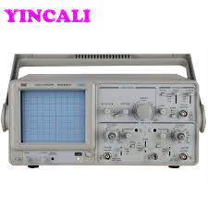

**DISPLAY:**

An oscilloscope display is divided into a screen and various channel controls.

* The display screen is divided into square divisions.
* Horizontal divisions represent time.
* Vertical divisions represent voltage.
* Axis position of a signal is also present on the screen.
* This position level can be changed with the help of buttons on the right side.
* The right side of screen contains front panel channel controls.
* It also has position level controls as well as time control.
* Each channel has its own voltage control as well as other signal aspect controls.

**INTERNALLY:**

Internally, an oscilloscope mainly cathode ray oscilloscope contains a Cathode Ray Tube. This tube along with a circuit generates signal waveforms on the screen for us.

**WORKING:**

* The oscilloscope is connected to the signal input.
* The channel we want to observe signal on is kept on while extra channels are turned off.
* Channel is grounded.
* The axis coordinates value of signal is set.
* The time per division is set.
* The voltage per division is set.
* The channel is switched to AC or DC.

**OUTPUT:**

Thus now, we get our desired signal by adjusting the values.

**CALCULATIONS:**

We calculate amplitude and frequency by observing the signal.

* For Voltage **peak-peak** , we count the number of divisions from the peak of signal to the bottom of the signal wave.
* For **AMPLITUDE,** we multiply the number of vertical divisions from maximum peak to the minimum peak with the voltage.

**AMPLITUDE = DIVMIN.PEAK-MAX.PEAK x Voltage**

* For **FREQUENCY,** we first multiply the number of horizontal divisions from start of cycle to end of cycle with the time per division for time period. Then we divide time period by 1

**FREQUENCY = 1 / Time Period**

Where,

**Time Period = Time per division x DIVCYC.START-CYC.END**

**FUNCTION GENERATOR:**

A function generator is usually a piece of electronic test equipment used to generate different types of electrical waveforms over a wide range of frequencies.

* It generates sinusoidal(sine), square, triangle and sawtooth waveforms.
* These are used in the development, testing and repairing of electronic equipment.
* A function generator may be able to vary the characteristics of the waveforms, changing the length of the pulse, i.e. edges of triangular or sawtooth waveforms.
* A typical function generator works on lower frequencies.

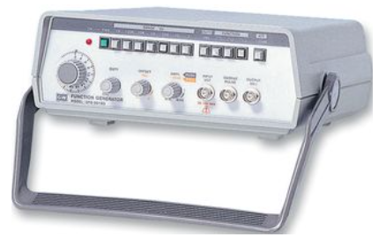

**WAVEFORMS:**

Function generator produces following types of waveforms.

1. Sine Wave.
2. Square Wave.
3. Triangular Wave.
4. Sawtooth Wave.
5. Pulse.

* **Sine Wave:**

A function generator is normally a sine wave generator. This is the standard waveform that oscillates between two levels with a standard sinusoidal shape.

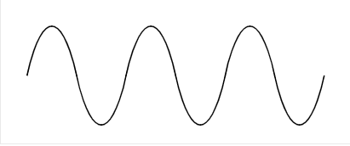

* **Square Wave:**

 Another waveform that can be produced by function generator is the square wave. It consists of a signal moving directly between high and low levels.

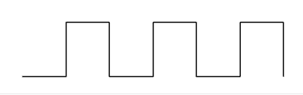

* **Triangular Wave:**

Another type of waveform that can be produced by a signal generator is Triangular waveform. This waveform linearly moves between a high and low point.

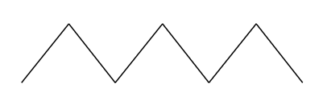

* **Sawtooth Wave:**

Another waveform that function generator can produce is known as sawtooth waveform. This is a triangular waveform, but with the rise edge of the waveform faster or slower than the fall, making a form of shape similar to a sawtooth.

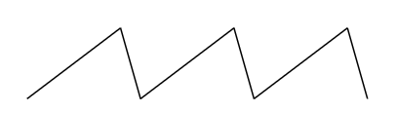

* **Pulse:**

Function generator can also produce pulses.

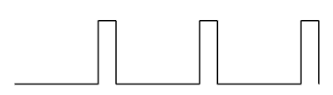

In addition to these waveforms, Function Generator has **frequency, waveform type, DC offset** and **Duty Cycle** controls.

**EXPERIMENT:**

We perform an experiment to analyze AC and DC signals across a simple circuit. First, we assemble the following circuit.

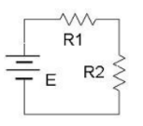

R1 = **33KΩ** R2 = **33KΩ**

* We find the following elements on your oscilloscope:

1. Channel-1 BNC input connectors.
2. Trigger BNC input connector.
3. Channel-1 select buttons.
4. Horizontal Sensitivity (or Scale) and Position knobs.
5. Vertical Sensitivity (or Scale) and Position knobs.
6. Trigger Level knob.

* The main display is similar to a sheet of graph paper. Each square will have an appropriate scaling factor or weighting, for example, 1 volt per division vertically or 2 milliseconds per division horizontally. Waveform voltages and timings may be determined directly from the display by using these scales.
* Select the channel-1 buttons. There should now be a horizontal line on the display. It may be moved via the Position knob.
* One of the more important fundamental settings on an oscilloscope is the Input Coupling.
* This is controlled via one of the bottom row buttons. There are three choices: Ground removes the input thus showing a zero reference, AC allows only AC signals through thus blocking DC, and DC allows all signals through (it does not prevent AC).
* Set the channel-1 Vertical Scale to 5 volts per division. Set the Time (Horizontal) Scale to 1 millisecond per division. Finally, set the input coupling to Ground and align the line to the center line of the display via the Vertical Position knob.
* Set the channel-1 Vertical Scale to 2 volts per division. Set the Time (Horizontal) Scale to 1 millisecond per division. Finally, set the input coupling to Ground and align the line to the center line of the display via the Vertical Position knob.
* Build the circuit shown in the figure using E=10V, R1=10kΩ and R2= 33kΩ. Connect a probe from the channel-1 input to the power supply (tip to plus, black clip to ground).
* Switch to DC coupling. The line should have deflected upward. Channel1 should be raised two divisions (2 divisions at 5 volts per division yields the 10 volt source).
* Connect a probe from channel-1 to R2 (again, tip to the high side of the resistor and the black clip to ground).
* Using this method, determine the voltage across R2 (remember, input-2 should have been set for 2 volts per division). Calculate the expected voltage across R2 using measured resistor values and compare the two in Table 1. Note that it is not possible to achieve extremely high precision using this method (e.g., four or more digits). Indeed, a
* DMM is often more useful for direct measurement of DC potentials. Double check the results using a DMM and the final column of Table 1.
* Select AC Coupling for the two inputs. The flat DC lines should drop back to zero. This is because AC Coupling blocks DC. This will be useful for measuring the AC component of a combined AC/DC signal, such as might be seen in an audio amplifier. Set the input coupling back to DC.
* Replace the DC power supply with the function generator. Set the function generator for a 1-volt peak sine wave at 1 kHz and apply it to the resistor network. The display should now show two small sine waves. Adjust the Vertical Scale settings for the two inputs so that the waves take up the majority of the display. If the display is very blurry with the sine waves appearing to jump about side to side, the Trigger Level may need to be adjusted.
* Also, adjust the Time Scale so that only one or two cycles of the wave may be seen. Using the Scale settings, determine the two voltages (following the method of step 7) as well as the waveform’s period and compare them to the values expected via theory, recording the results in Tables 2 and 3. Also crosscheck the results using a DMM to measure the RMS voltages.
* To find the voltage across R1, the voltage across R2 must be subtracted through the circuit voltage
* One of the more useful aspects of the oscilloscope is the ability to show the actual wave shape. This may be used, for example, as a means of determining distortion in an amplifier.
* Change the wave shape on the function generator to a square wave, triangle, or other shape and note how the oscilloscope responds. Note that the oscilloscope will also show a DC component, if any, as the AC signal being offset or “riding on the DC”. Adjust the function generator to add a DC offset to the signal and note how the oscilloscope display shifts. Return the function generator back to a sine wave and remove any DC offset.

**OBSERVATIONS:**

R1 = 4.7KΩ & R2 = 2.4KΩ

**DC:**

**For R1:**

|  |  |  |  |  |
| --- | --- | --- | --- | --- |
|  | Scale (V/Div) | # Of Divisions | Voltage Peak-Peak | Voltage RMS |
| Oscilloscope | 1 | 4.4 | 4.4 V | 4.4 V |
| Theoretical | _________ | _________ | 4 V | 4 V |

**For R2:**

|  |  |  |  |  |
| --- | --- | --- | --- | --- |
|  | Scale (V/Div) | # Of Divisions | Voltage Peak-Peak | Voltage RMS |
| Oscilloscope | 1 | 1.2 | 1.2 V | 1.2 V |
| Theoretical | _________ | _________ | 1 | 1 |

**AC:**

**For R1:**

|  |  |  |  |  |
| --- | --- | --- | --- | --- |
|  | Scale (V/Div) | # Of Divisions | Voltage Peak-Peak | Voltage RMS |
| Oscilloscope | 2 | 2.2 | 4.4 V | 3.11 V |
| Theoretical | _________ | _________ | 4 | 2.82 V |

**For R2:**

|  |  |  |  |  |
| --- | --- | --- | --- | --- |
|  | Scale (V/Div) | # Of Divisions | Voltage Peak-Peak | Voltage RMS |
| Oscilloscope | 2 | 0.6 | 1.2 V | 0.85 V |
| Theoretical | _________ | _________ | 1 V | 0.70 V |

**For Frequency and Time Period:**

|  |  |  |  |  |
| --- | --- | --- | --- | --- |
|  | Scale (S/Div) | # Of Divisions | Time Period | Frequency |
| Oscilloscope | 5 ms | 1 | 5ms | 1600Hz |

**CONCLUSION:**

We concluded the oscilloscope is a very useful device. It can be used for analysis of different kind of electric circuits. We can measure voltage drop across resistors with the help of oscilloscope. On the other hand, we can also plot voltage vs time graph with the help of oscilloscope.